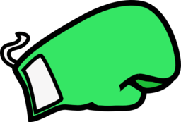
1.
Right Jab – Left Jab

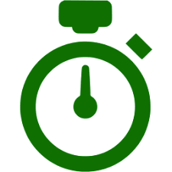
Retreat & Repeat
2.
15 seconds quick uppercuts (right and left)

Retreat & Repeat
3.
Left Jab

Retreat & Repeat
4.
Step Up – Right Jab – Left Jab

Repeat
5.
Right Jab – Left Jab – Right Uppercut – Left Uppercut

Retreat & Repeat
6.
15 seconds quick left jab – turn and jog

Repeat
7.
Left Jab – Right Jab – Left Hook

Retreat & Repeat
8.
Right Jab

Retreat & Repeat
9.
Right uppercut – Left uppercut – Squat

Repeat
10.
Step Up – Right Jab – Left Jab

Repeat
11.
15 seconds quick right jab
Retreat & Repeat
12.
Right Jab – Left jab – Right Hook – Left Uppercut

Retreat & Repeat

