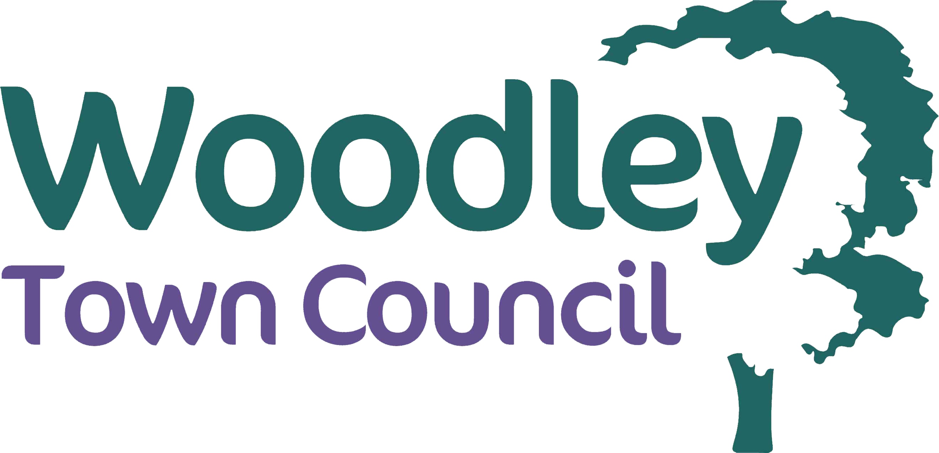

Community Heroes Awards Nomination Form - 2023
Each year, Woodley Town Council celebrates the work of people and organisations who help others and contribute to our community at its Community Heroes Awards ceremony.
The Mayor will present the awards at a Civic Reception, to which the award winners, their family and friends, and the nominators are invited. The next Community Heroes Awards ceremony will be on 24 February 2023.
The awards are for individuals and organisations whose good works benefit an individual or organisation in Woodley. They can be good neighbours, people or organisations who carry out voluntary work, or those who care for people in our community. Nominees can be any age and there is a youth category for nominees aged 19 or under.
Community Heroes Awards are presented in six categories, as follows:
  - Community Heroes - Neighbour of the Year – Awarded to an individual who has, independently (ie not part of a wider charity organisation) provided exceptional care and support to a Woodley resident or residents within their local community
  - Community Heroes - Volunteer of the Year – Awarded to an individual who has, as part of a voluntary or charity organisation, provided exceptional support to the activities of the organisation, making a difference to residents of Woodley
  - Community Heroes - Voluntary Group of the Year – Awarded to an organisation that has provided exceptional support and services to Woodley residents
  - Community Heroes - Climate Champion of the Year – Awarded to an individual, organisation or group that has made a significant contribution to fighting climate change and / or climate initiatives within the area
  - Community Heroes - Young Person of the Year – Awarded to an individual aged 19 or under who, through voluntary activities, has made an exceptional contribution to the Woodley community
  - Community Heroes - Mayor’s Outstanding Contribution Award – Awarded by the Mayor to an individual or organisation who they feel have provided an outstanding contribution to the community
If you know an individual or organisation you think deserves recognition for their work in our town you can make a nomination by filling in this form and returning it to the Council, either via email to matthew.filmore@woodley.gov.uk, or in person at the Town Council offices, by 16 November 2022.

The guidelines for nominations are provided below:
- No serving Town Councillor or Officer may make or receive an award.
- Nominees cannot be nominated for their work in a field in which they are also in paid employment.
- Nominees must have made a significant contribution to an individual, a group of people or an organisation in Woodley.
- Nominations will be accepted for nominees living outside Woodley, as long as the main focus of their good works is to the benefit of a person or people living in Woodley.
- Nominees can be any age.
- Nominees for the youth award must be aged 19 or under at the time of making the nomination.
- Nominees who have received an award in a previous year are not eligible to receive a further award in recognition of the same or similar voluntary activities. However, nominees may receive further awards where they are nominated for significantly different voluntary activities. This decision will be up to the discretion of the committee that considers the nominations.
- One award will presented per category each year. However the Committee reserve the right to present multiple awards within a particular category or to not present an award dependent on the merit of the nominations received.
- Any canvassing of members of the committee that considers the nominations will result in that nomination not being considered.
- The decision of the committee on the awards is final and no correspondence will be entered into regarding any decision.
- Nomination forms must be completed by two nominators.
For further information please contact Matthew Filmore, Committee Officer 0118 969 0356 / matthew.filmore@woodley.gov.uk

COMMUNITY HEROES AWARDS
NOMINATION FORM

FIRST NOMINATOR’S DETAILS
Your Name:
Your Address:
Your Tel. No.:
Your Email:
NOMINEE’S DETAILS
Nominees’ Name:
Nominees’ Address:
Nominees’ Tel. No.:
Nominees’ Email
NOMINATION DETAIL
Which Community Hero Award do you believe your nominee should be considered for*? (Please tick) |  | Neighbour of the Year
 |  | Volunteer of the Year
 |  | Voluntary Group of the Year
 |  | Climate Champion of the Year
 |  | Young Person of the Year
*Please note the Committee reserve the right to consider your nominee in a different category where they deem it is appropriate.
Please tell us your reasons for making this nomination, providing as much detail as you can about the individual / organisation, their activities, and why you feel they deserve to be recognised as a Community Hero:
…Continued…
DECLARATION
I declare that the individual / organisation I have nominated is not aware of this nomination and that, to the best of my knowledge, the reasons for this nomination and the information I have provided are true and correct.
Signed:
Print:
Date:
SECOND NOMINATOR’S DETAILS
Your Name:
Your Address:
Your Tel. No.:
Your Email:
NOMINATION DETAIL
Please tell us your reasons for making this nomination, providing as much detail as you can about the individual / organisation, their activities, and why you feel they deserve to be recognised as a Community Hero:
DECLARATION
I declare that the individual / organisation I have nominated is not aware of this nomination and that, to the best of my knowledge, the reasons for this nomination and the information I have provided are true and correct.
Signed:
Print:
Date:
Your privacy is important to us and we will only keep your information for the purposes for which it was submitted. You can find out more about how we use your data from the Privacy Notice available on our website www.woodley.gov.uk

