Project Assessment

05 | 05/07/22
Project/policy/service: | TRACTOR MOUNTED SPIKER
Cost | £3,000 est
Priority | 2
Completed by: | Kevin Murray, Deputy Town Clerk

- Project/policy/service information:
This section should identify the project, policy or service change, the method of delivery and the key stakeholders, main beneficiaries and associated aims. It should also include information regarding the Health & Safety, Legal Compliance and Income Impacts.

What is the purpose of the project, policy change or service change and what are the expected outcomes:
New unit required for spiking sports pitches to improve drainage. The existing unit is over 20 years old, beyond economical repair and has scrapped. Spiking is essential for drainage and aerating the soil to provide quality sports surface.
Outline how the project, policy change or service change will be delivered and what governance arrangements are in place or required:
Purchase
Outline the main beneficiaries of the project, policy change or service change:
Public / Park Users / Staff
Impact | Y/N | Detail
Health /Safety Impact | Y | Will improve safety of task
Legal Compliance | Y | Health & Safety at Work Act
Income Impact | Y | Pitches and grounds are key income generator
Other | Y | Amenity Improvement/maintenance

- Equality Impacts - Protected characteristics:

There are 9 protected characteristics as identified by the legislation. Consideration should be given to the potential impacts on each of these groups.
- Race
- Gender
- Disability
- Gender re-assignment
- Age
- Religious belief
- Sexual orientation
- Pregnancy/Maternity
- Marriage and civil partnership

The table below should indicate whether the project, policy change or service change will have a positive or negative impact on any of the protected characteristic groups. Each group should be assessed and assigned a Positive, No, Low or High impact score.

Protected characteristics | Impact score | Please detail what impact will be felt by the protected group
Race | None
Gender | None
Disabilities | Positive | Equipment required to maintain green spaces to provide access for all users.
Age | None
Sexual orientation | None
Religion/belief | None
Gender re-assignment | None
Pregnancy & maternity | None
Marriage & civil partnership | None

Based on the initial impact assessment, a more detailed assessment should be carried out where any groups have been identified as having a low or high negative impact.

- Environmental Impacts

Impact | Y/N | Detail
Carbon impact | Y | No suitable lower carbon alternatives currently available
Habitat/biodiversity impact | N
Alternatives considered | Y | Electric alternatives considered. No units currently available that could be used for this purpose.

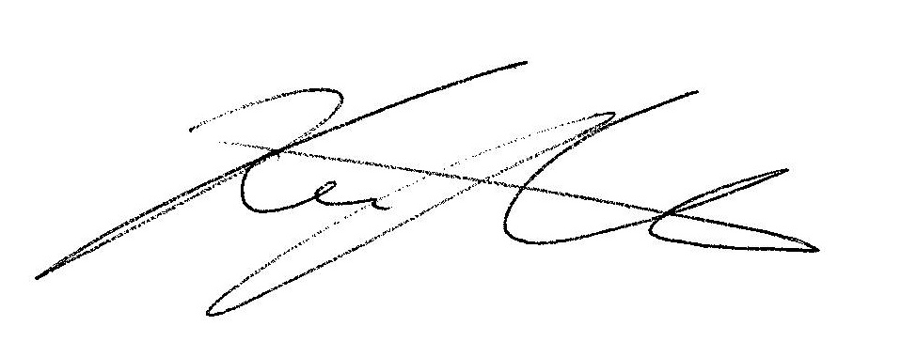

Signed: _________________________________ Print: Kevin Murray Date: 05/07/22

